**PmWebSpec Application Setup User Guide**

# **Application Introduction**

PmWebSpec is a web-based application developed using CodeIgniter based PHP Programming language (Version 5.5 – 8.0). Frontend is developed in HTML5, CSS, JavaScript, Bootstrap and MySQL as database.

# **Application Architecture**

**Backend** - PHP CodeIgniter (MVC Structure)

**Database** – MySQL

**Frontend Tech** – HTML5, JavaScript, CSS, Bootstrap

# **Software Setup**

## **3.1 Local Setup**

*Note: - The installation process is specific to Windows OS and steps may differ for other operating systems.*

* XAMPP Server (PHP 8.0 - Recommended)
* Any Editor (Sublime - Preferred) **- Optional**

**XAMPP Server Setup:** Installing this XAMPP server will install both PHP and MySQL database.

* 1. Download XAMPP server from <https://www.apachefriends.org/download.html>

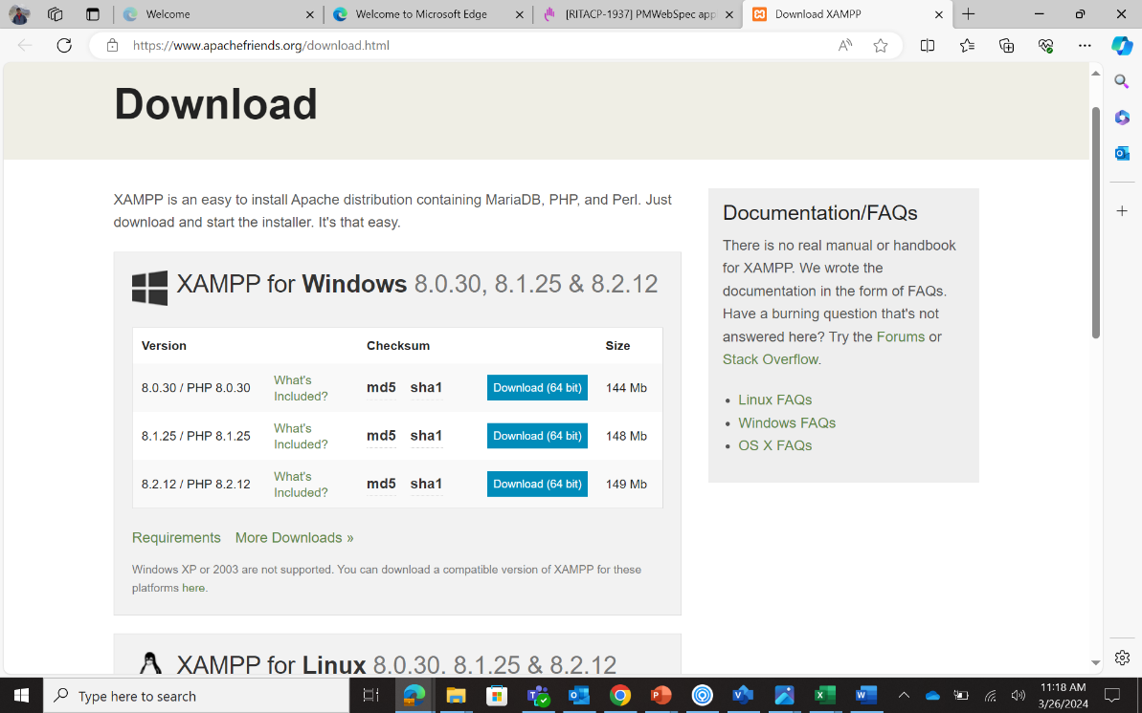

* 1. Download and install exe file according to the operating system.
* If you get the following warning sign, click on OK and ignore it.

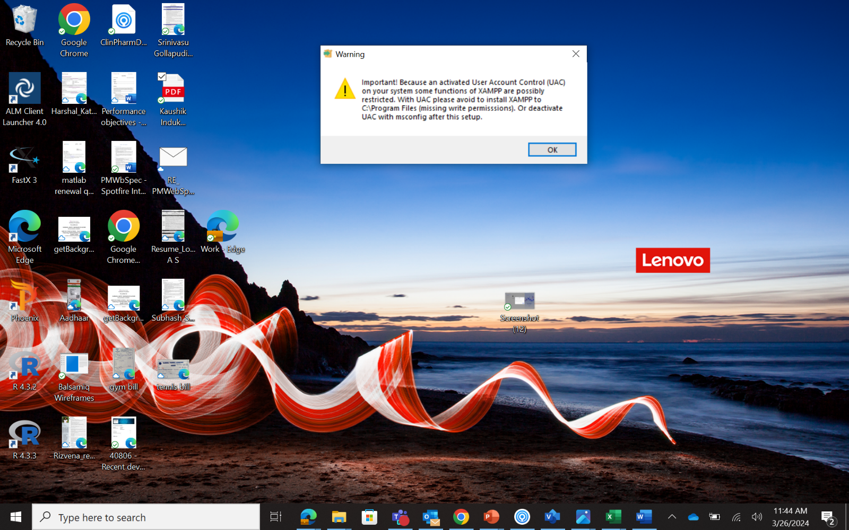

* If you receive any other warning from Windows Defender, click on Allow access button and continue
* Preferred installation location is C:\ drive
* During installation, by default all the boxes are checked to be installed. If not, make sure that MySQL and phpMyAdmin are checked and continue to the next steps

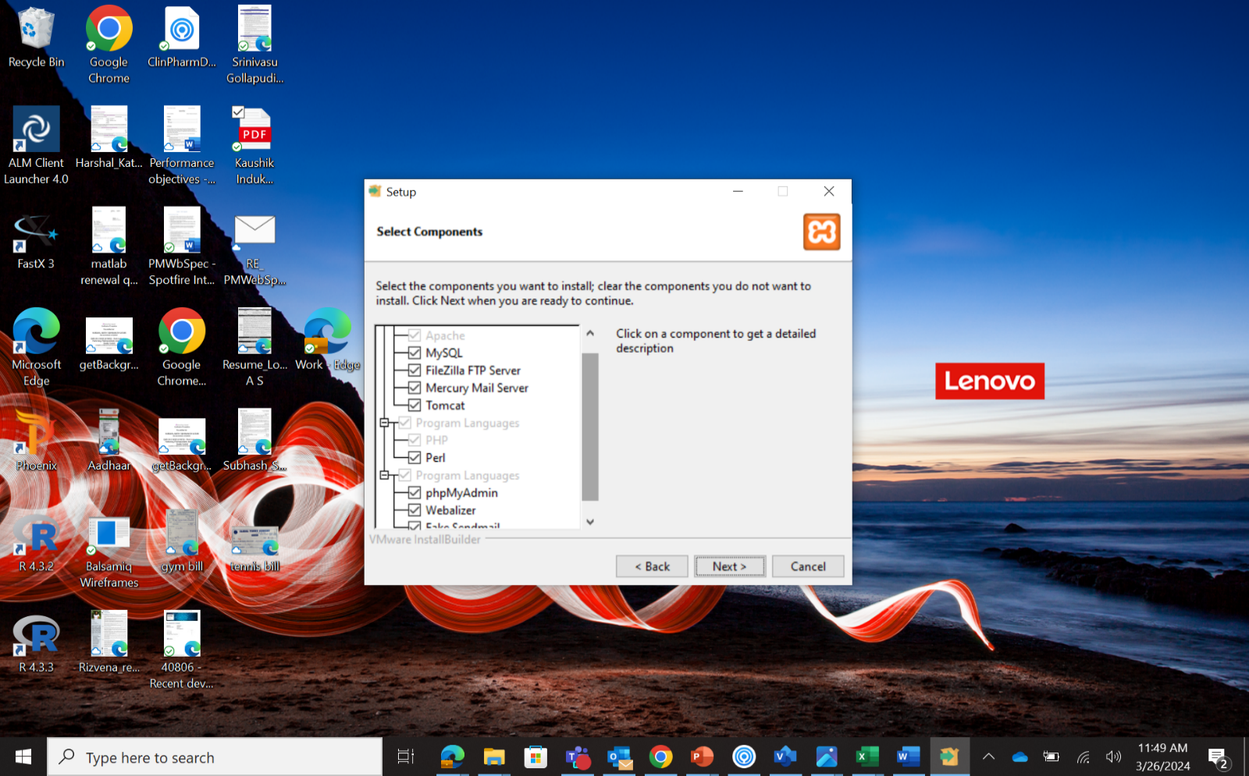

* After successful installation of XAMPP, system will generate auto created folder named ‘xampp’ in **C:\** location
  1. Launch XAMPP and start Apache and MySQL server from toolbar and click on the start button in front of apache and MySQL service

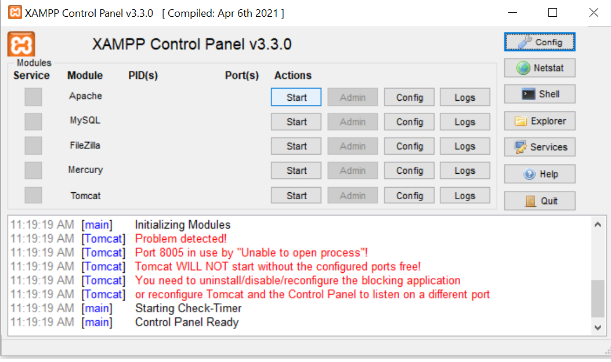

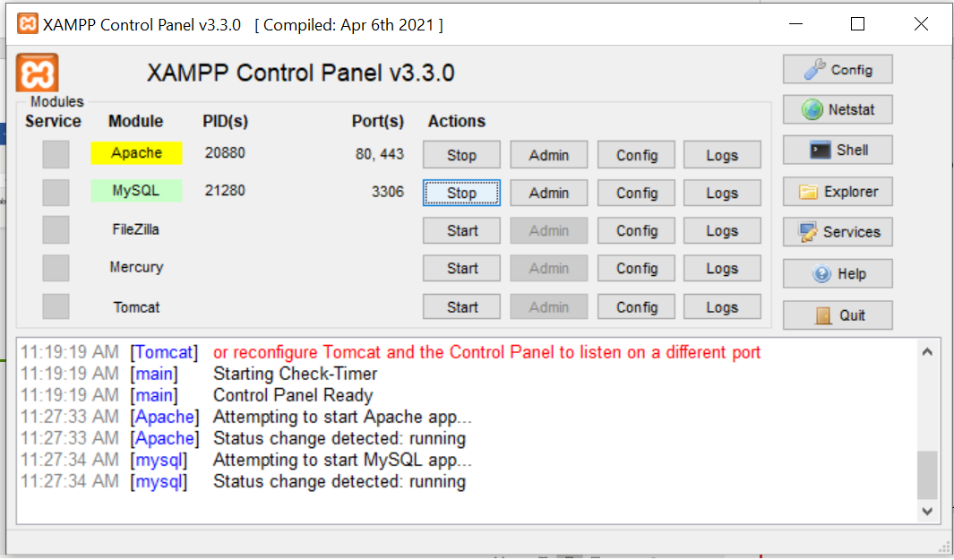

* 1. After XAMPP setup, application server is started.

## **3.2 Code Setup**

* 1. Go to [GitHub - BMS-CPP/PMWebSpec](https://github.com/BMS-CPP/PMWebSpec) and download the zip file for PmWebSpec using the “Download ZIP” option when you click on the green "Code” button.

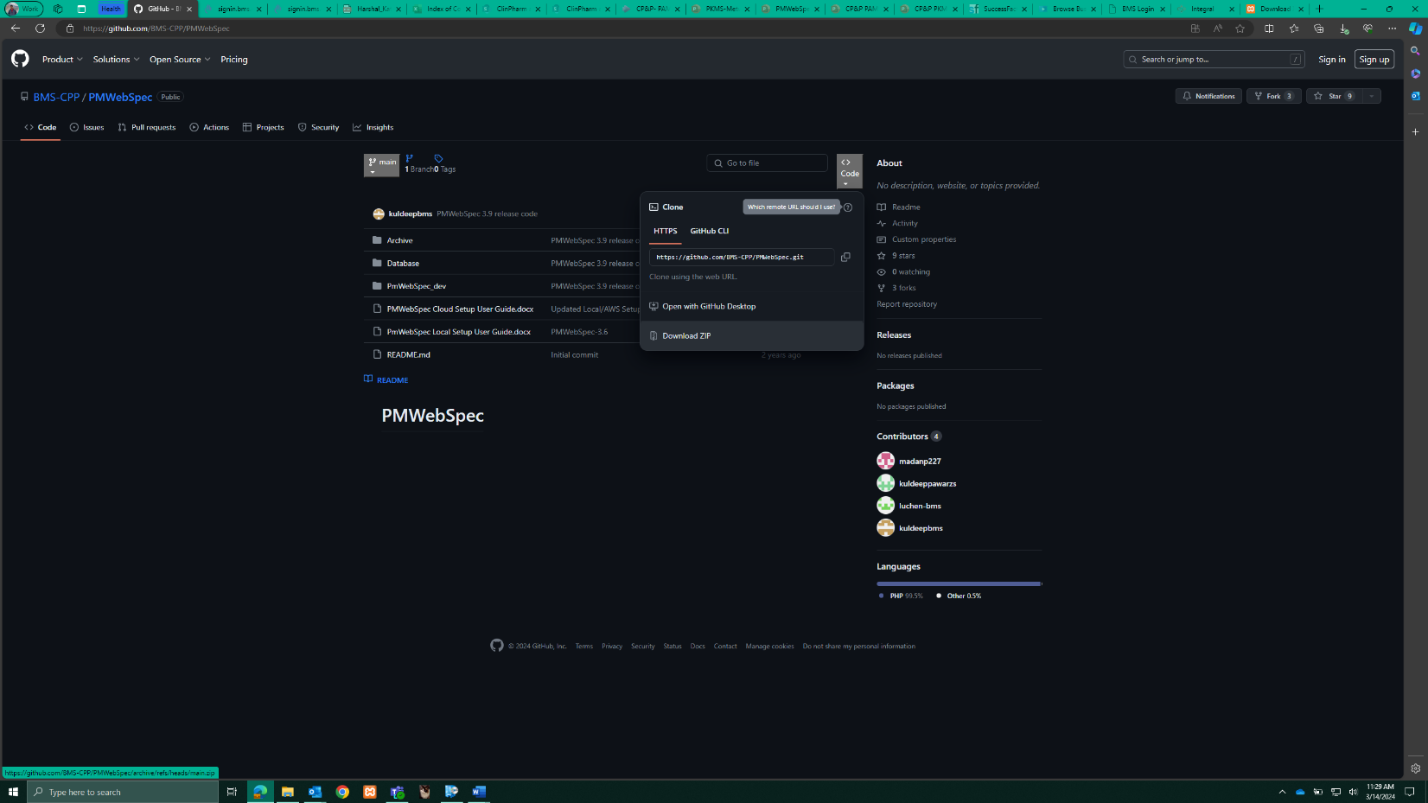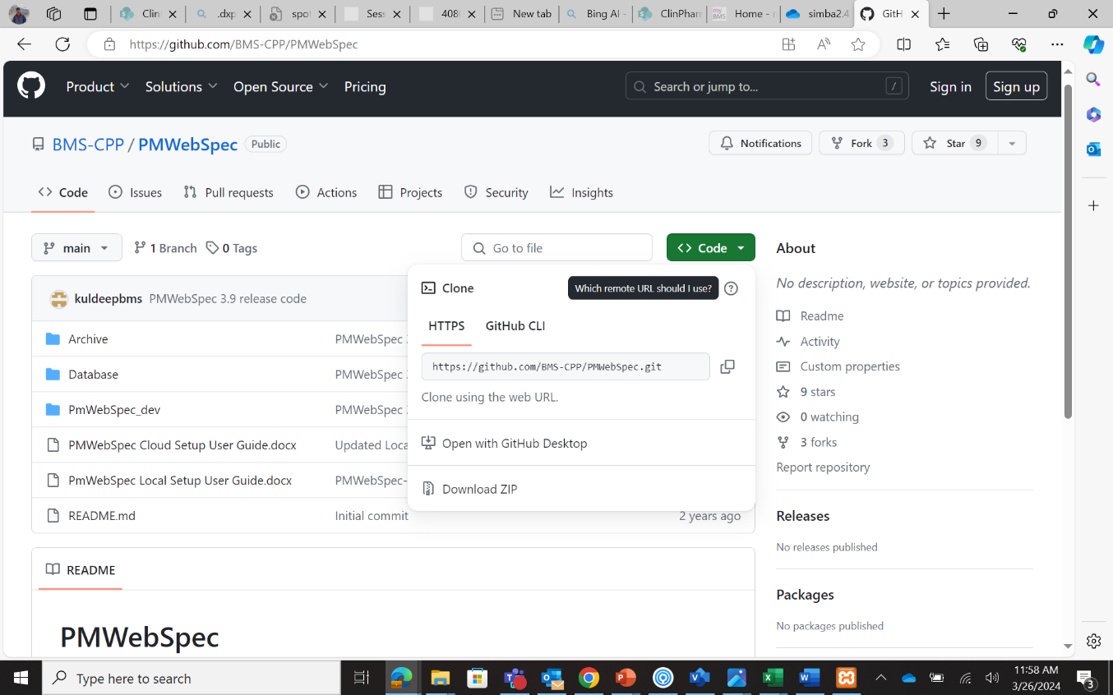

* 1. Extract the zip file ‘PMWebSpec-main’. The PmWebSpec_dev in this main folder will need to be copied to **C:\xampp\htdocs\**

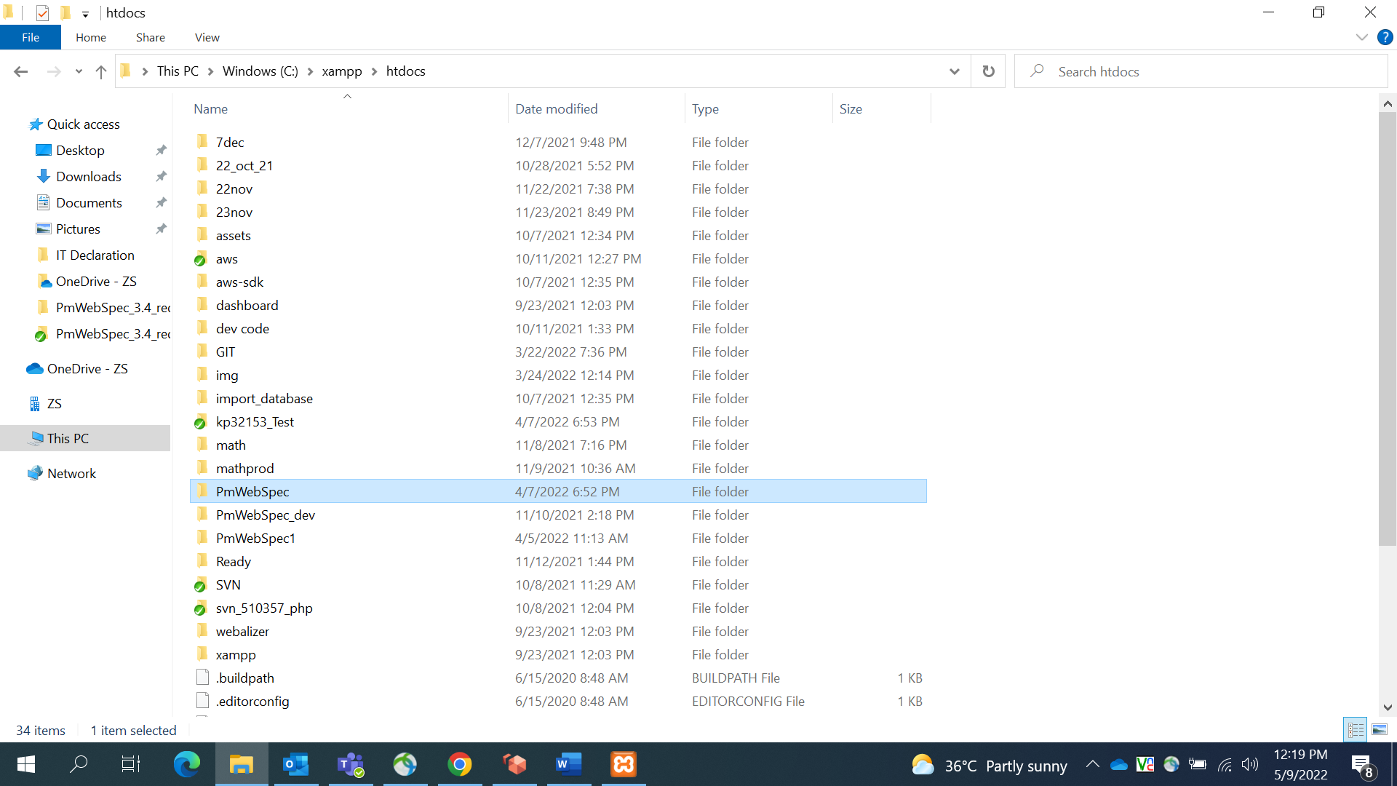

## **3.3 Database Configuration**

**Databases** – PmWebSpec contains two databases.

* dbstruct_ci_test.sql
* web_based_spec_ci_test.sql

**Steps for importing Database**

1. Go to PhpMyAdmin page (<http://localhost/phpmyadmin>)

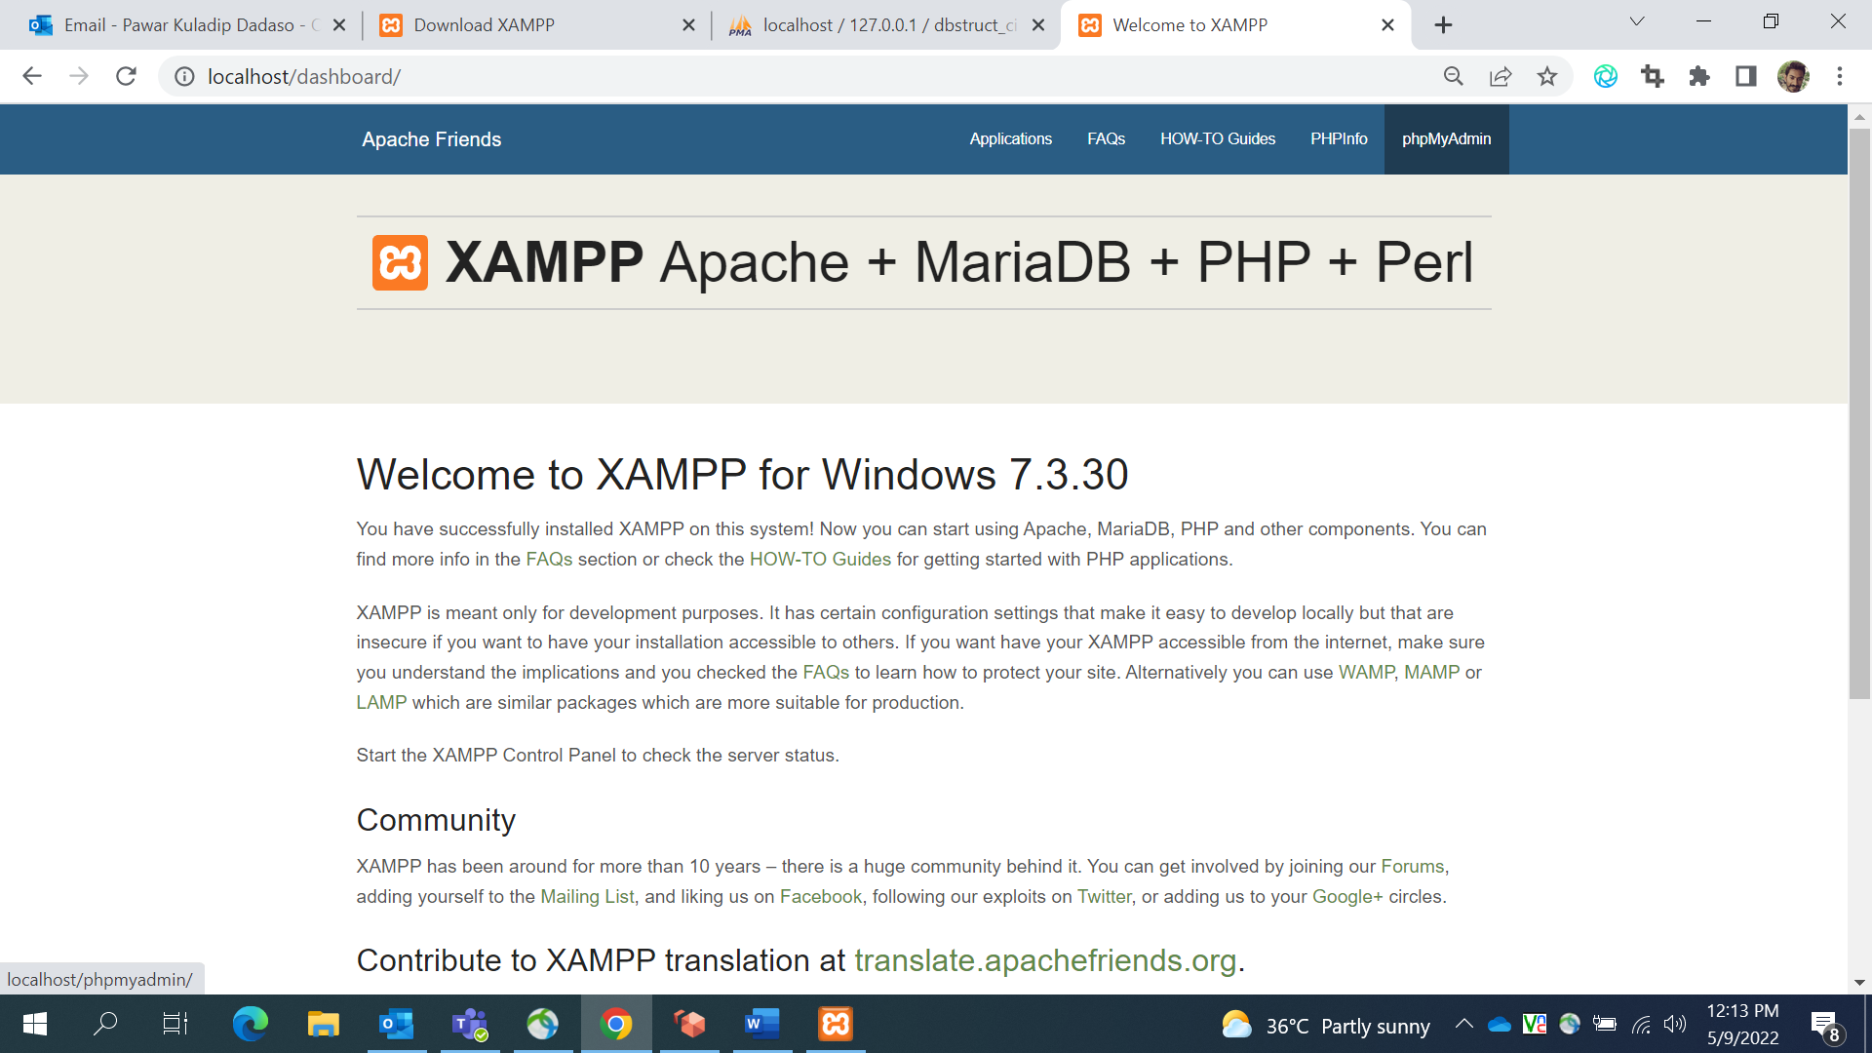

1. Create Database – dbstruct_ci_test and web_based_spec_ci_test

2.1 Enter the database name as “dbstruct_ci_test” in the respective field, and select the collation type from the dropdown and click on Create.

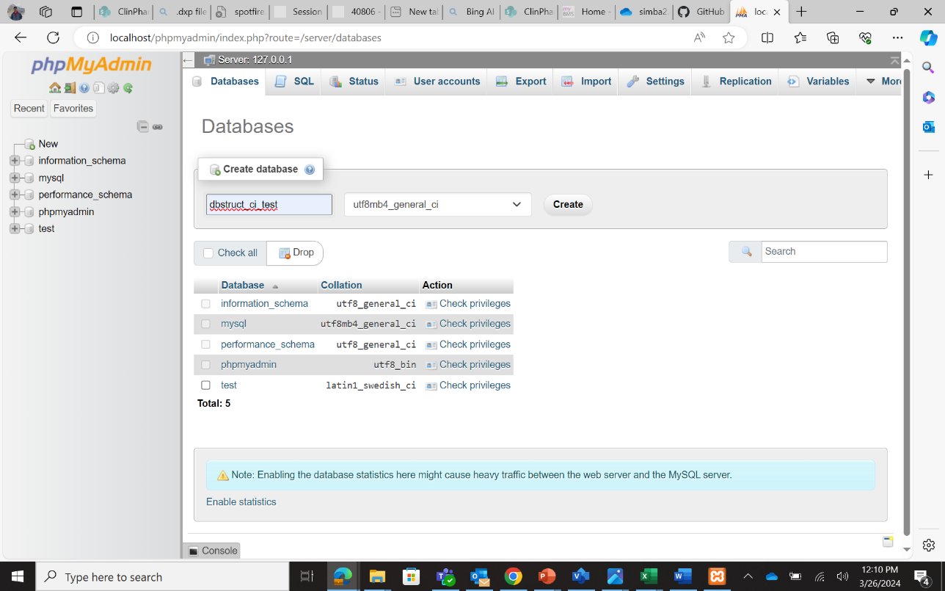

**CLICK HERE**

2.2 Enter the database name as “web_based_spec_ci_test” in the respective field, and select the collation type from the dropdown as shown and click on Create. Other databases are default and are created by the system.

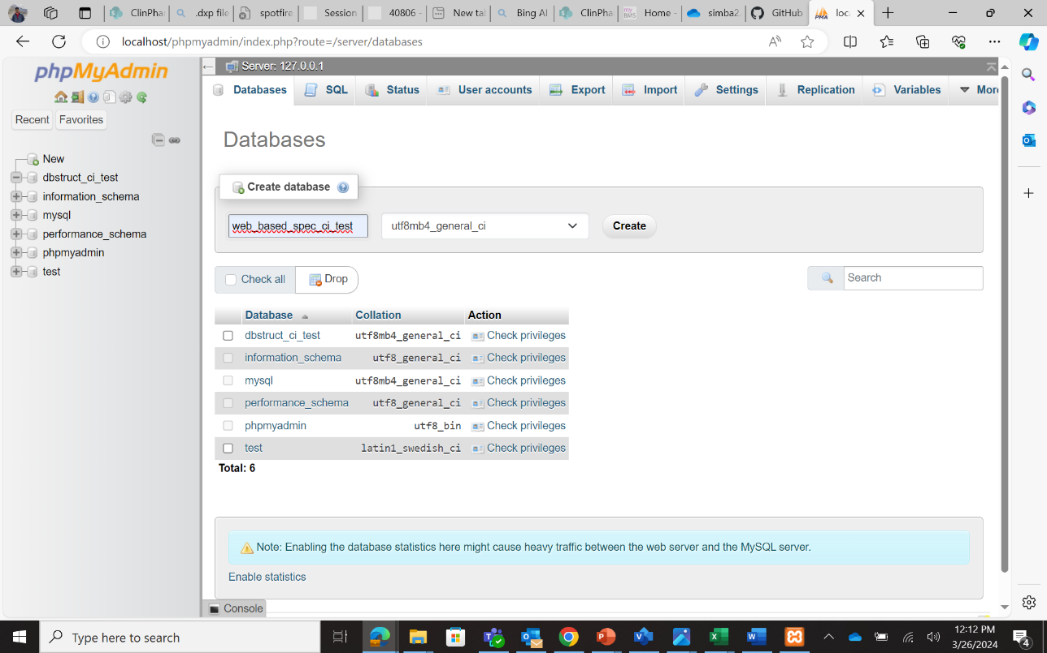

**CLICK HERE**

1. Go to <https://github.com/BMS-CPP/PMWebSpec/tree/main/Database>, download the 2 database files and save them in your computer. You can also find the files in the zip file you downloaded in section 3.2 (under /PMWebSpec-main/Database/).

* dbstruct_ci_test.sql
* web_based_spec_ci_test.sql

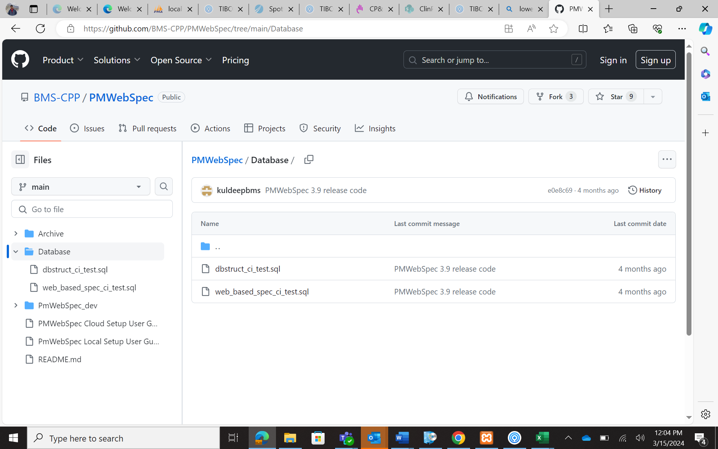

**CLICK HERE**

**CLICK HERE**

1. To download the files, click on either of the files. A new page opens. Click on the “Download raw file” button as shown and save the file in your desired location.

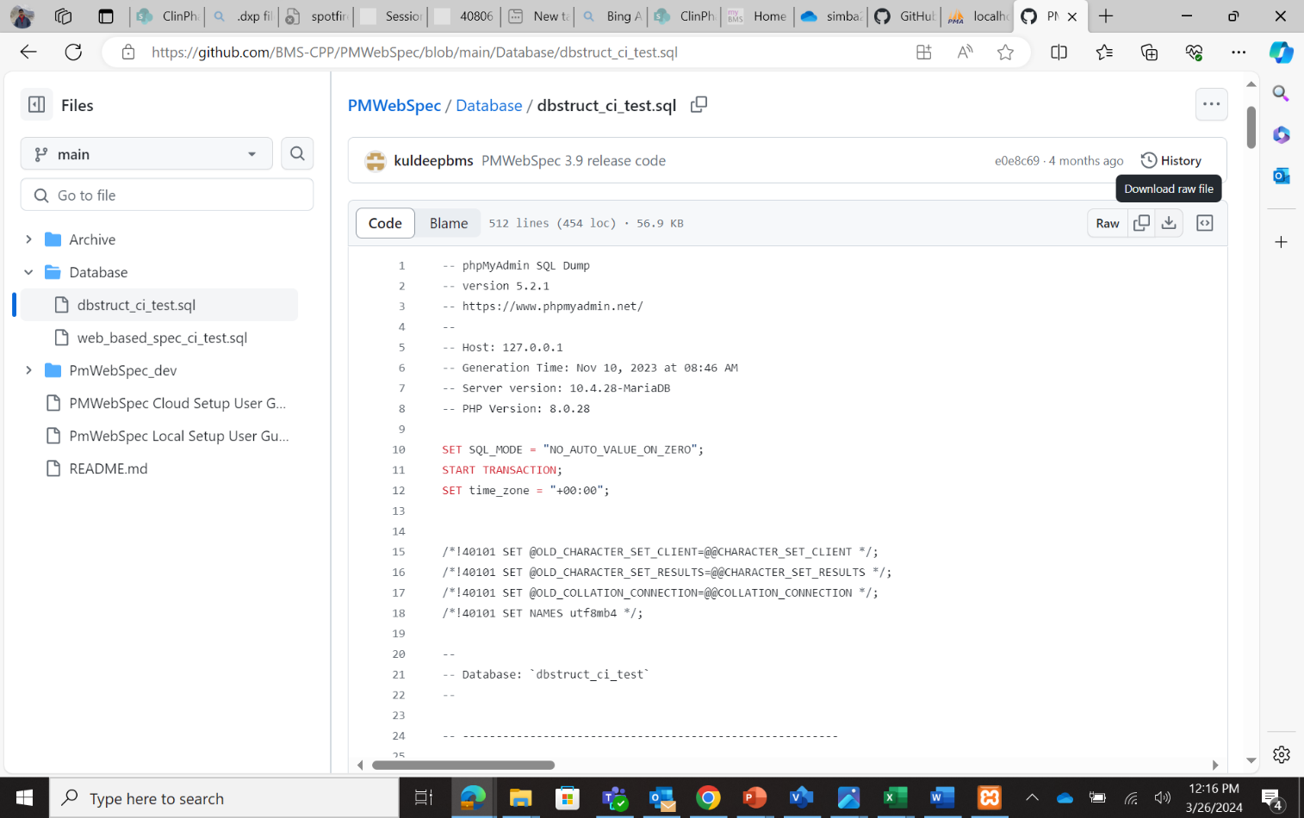

**CLICK HERE**

1. 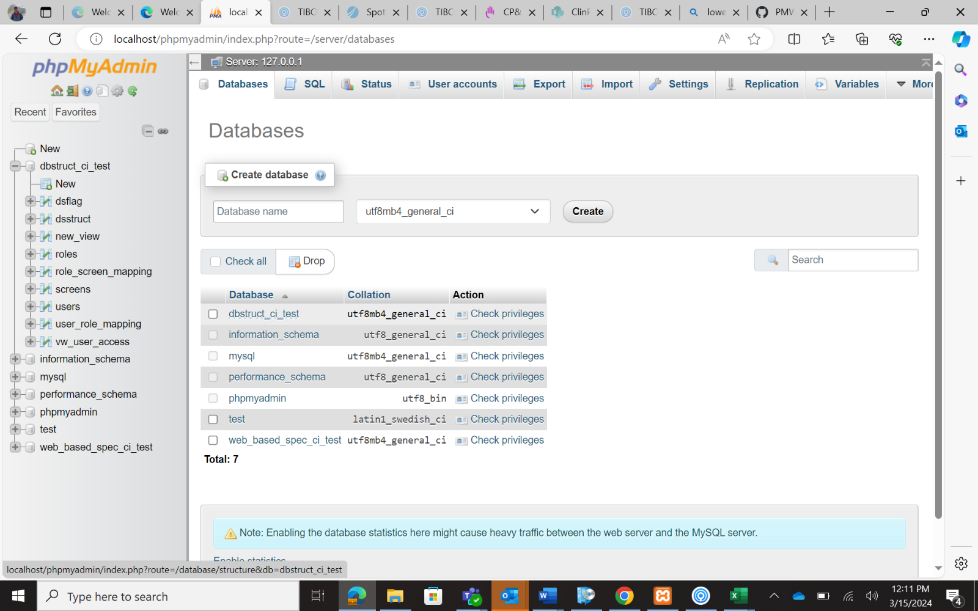After creating the database, open one of the databases from the Databases tab by double clicking on the name. Select dbstruct_ci_test database to open.

**DOUBLE CLICK HERE**

1. After database opens, 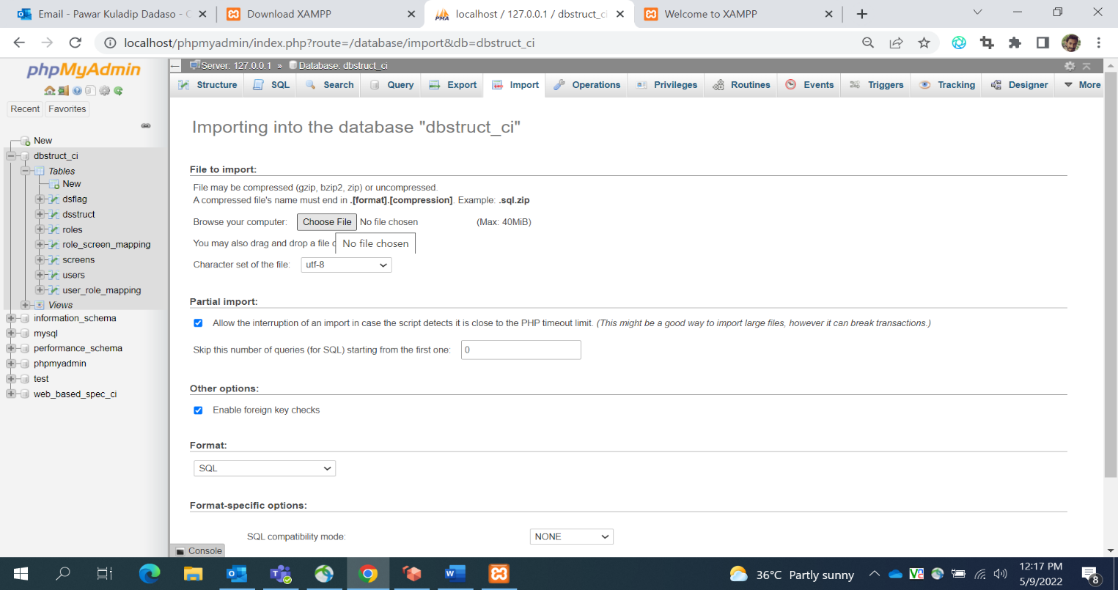go to Import tab as highlighted and choose dbstruct_ci_test.sql file downloaded from step 3 or 4 from your local computer.

**CLICK HERE TO CHOOSE FILE**

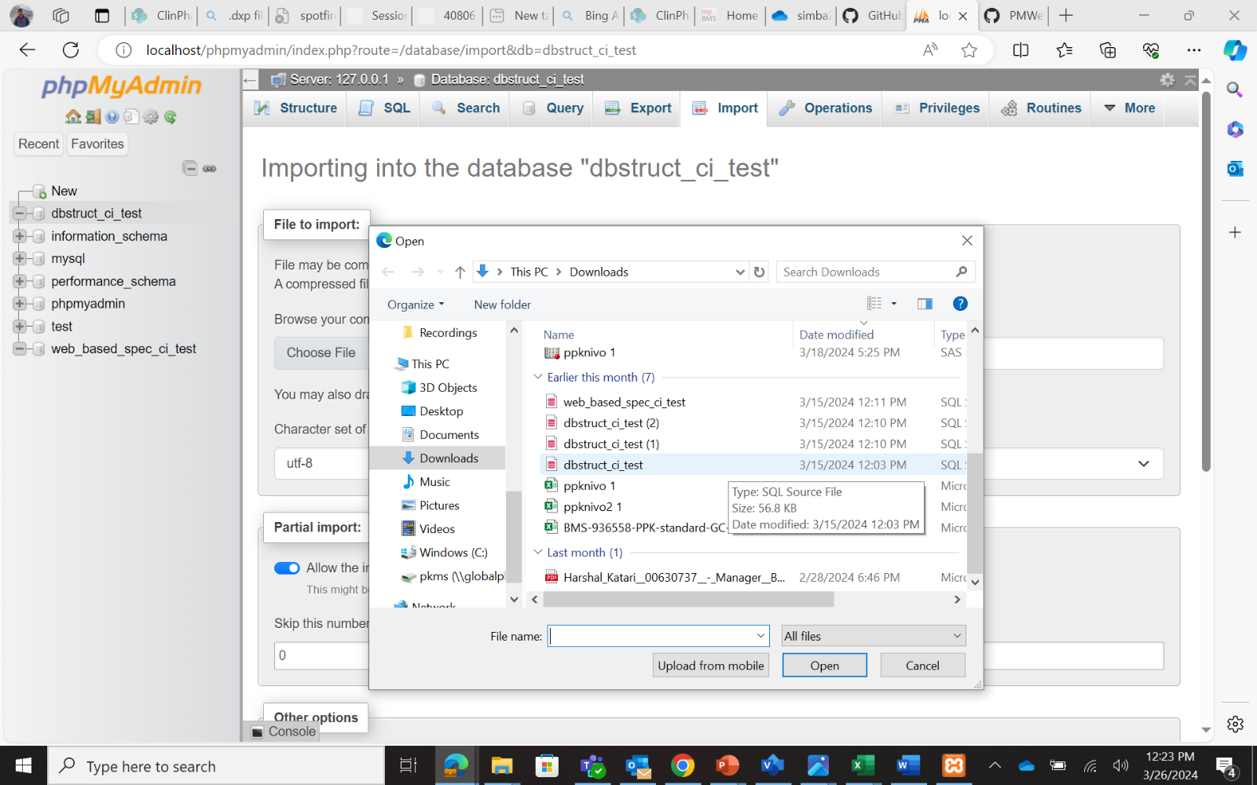

1. 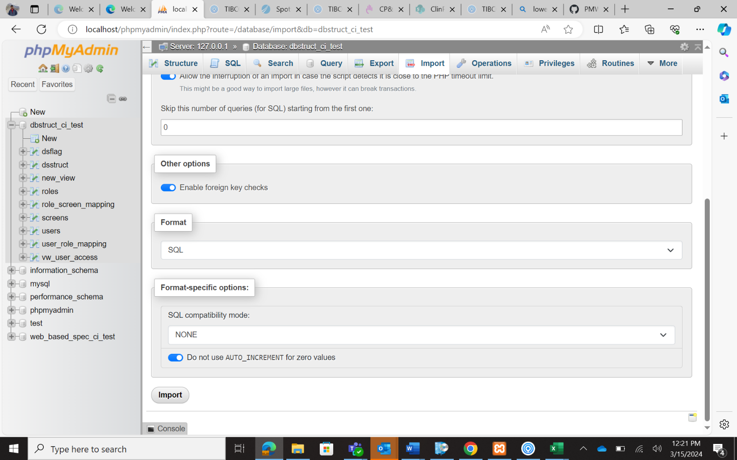Click on the “**Import**” button at the bottom of the screen to submit.

**CLICK HERE TO IMPORT**

1. 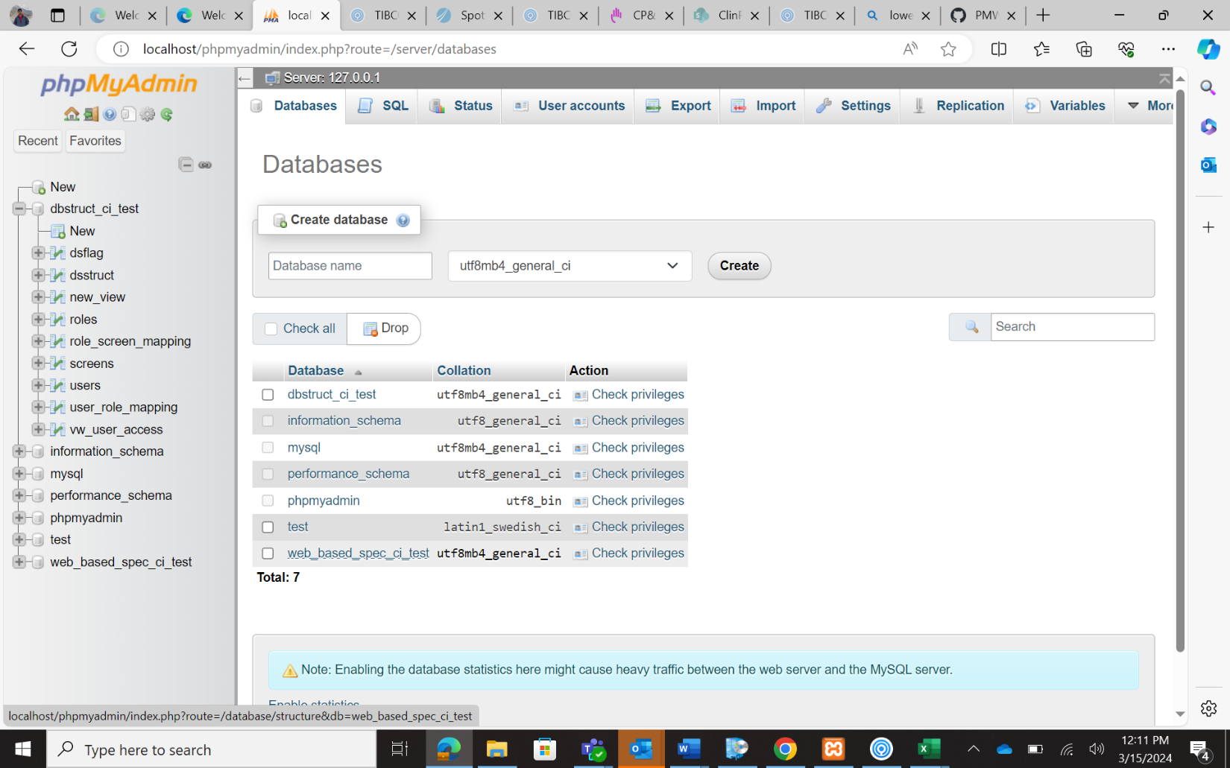To import web_based_spec_ci_test database, click on the “Database”" option to go back from the current databases. Double click the web_based_spec_ci_test database and repeat step 4-7 to import it.

**DOUBLE CLICK HERE**

**CLICK HERE TO GO BACK FROM CURRENT DATABASE**

1. To grant all access rights for pmwebspecadmin in local system, execute the below mentioned command in dbstruct_ci_test database in the “SQL” tab and click on “Go” button.

**GRANT ALL ON *.* TO 'pmwebspecadmin'@'%' IDENTIFIED BY 'complex-password';**

* 1. Run the application on local using the URL - <http://localhost/PmWebSpec_dev/home>

